**Array of Objects**

Create a Java program to manage a set of computers in a lab. The program should contain three classes: Computer, Lab and LabTester (which consists of the main method).

The Computer Class

• Create all the necessary fields for the class as well as their accessor and mutator methods (get and set). The following information of each computer needs to be tracked: serial number, manufacturer, year of made, year of purchase, processor speed, size of RAM, and warranty expiry year.

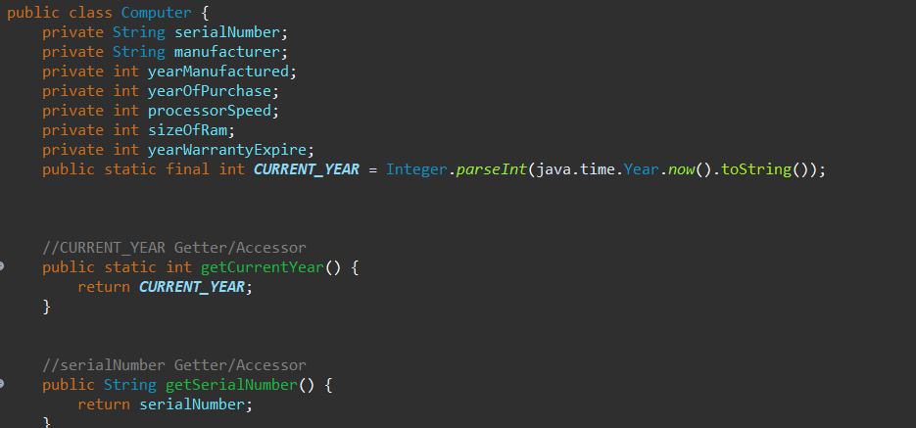

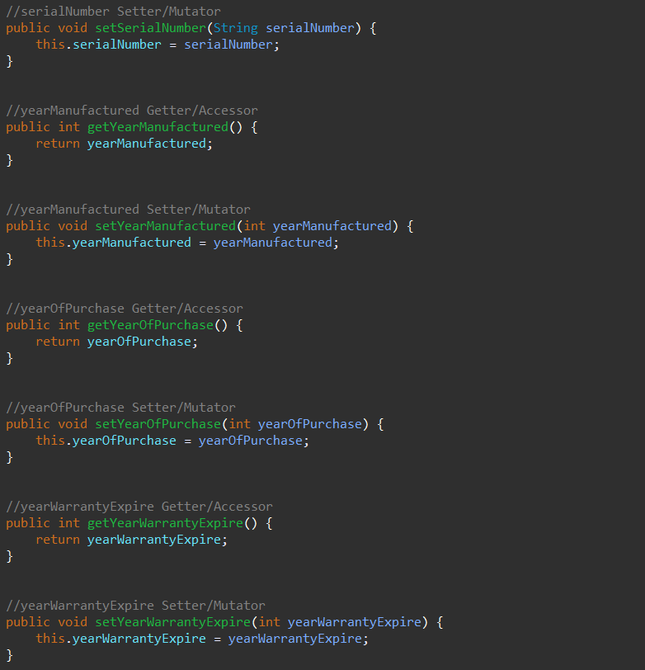

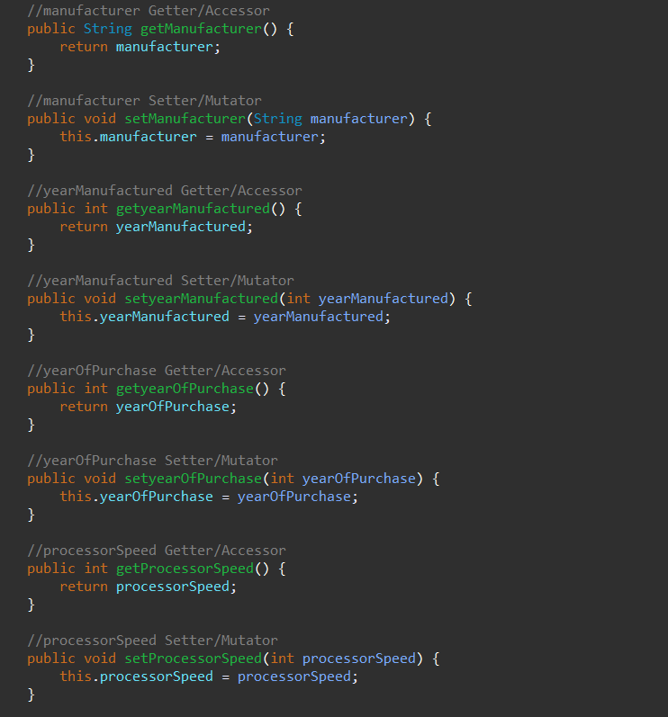

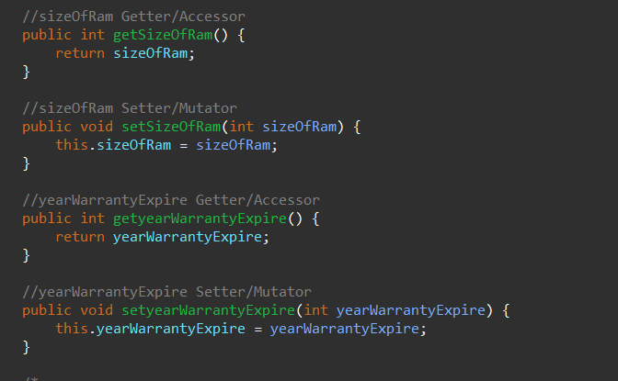

• Create a constructor that initializes the instance variables of the object being constructed.

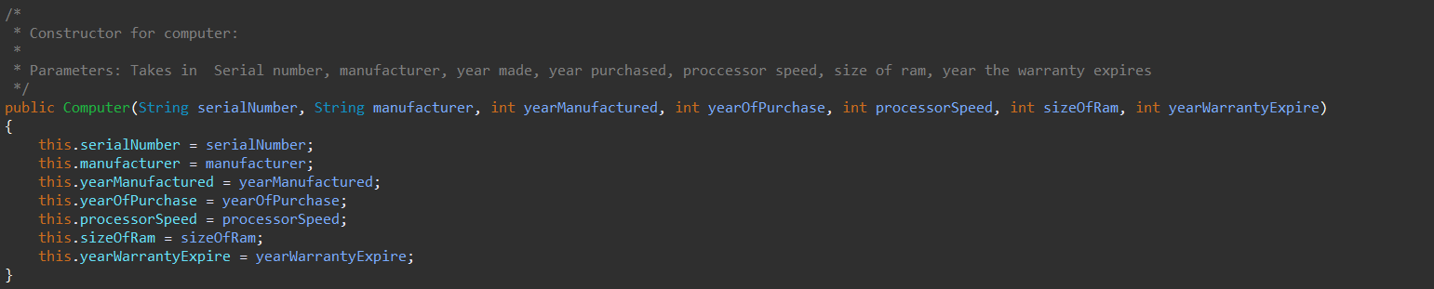

• There should be the toString method which allows the output of the above information in an organized manner.



• Different computers will be compared on their speed, RAM size, and age, therefore there needs methods for these comparison.

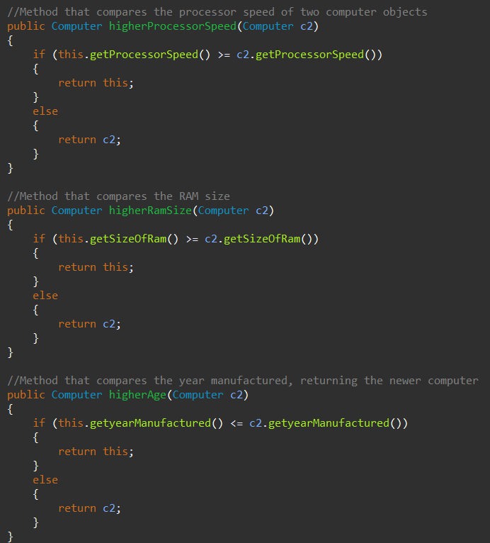

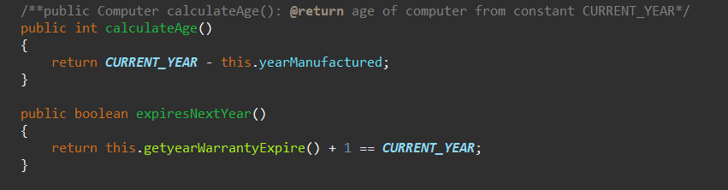

The Lab Class

Create a Java class “Lab” to manage the set of computers in a lab. The “Lab” class should contain the following:

• The maximum capacity of the lab

• The number of computers installed

• An array used to store the computers

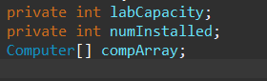

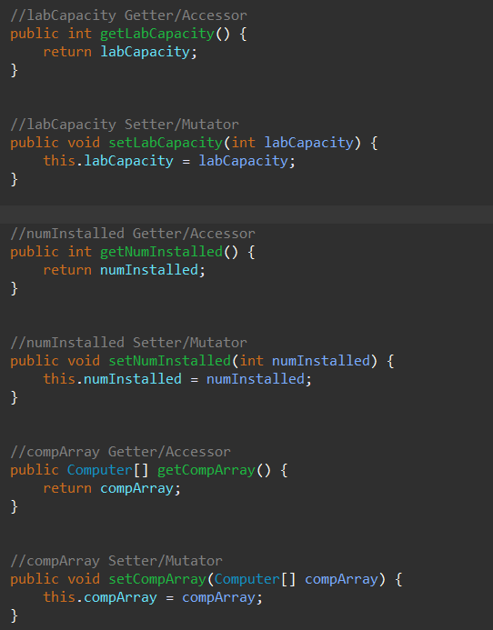

• A constructor that initiate the maximum capacity and create an array of appropriate size

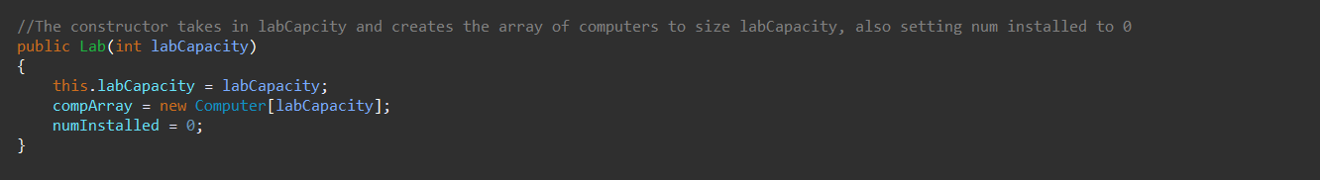

• A method installComputer which takes the information of a computer as parameter, then create a “Computer” object accordingly and insert it into the array.

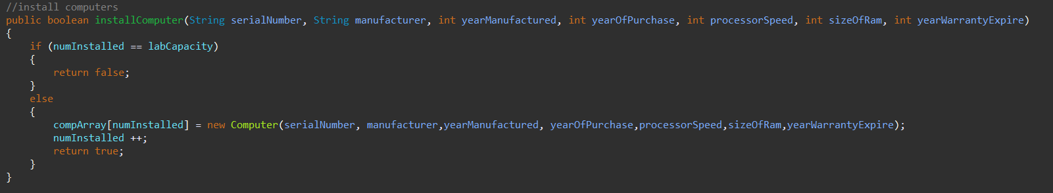

• A method that calculates the average age of the computers in the lab

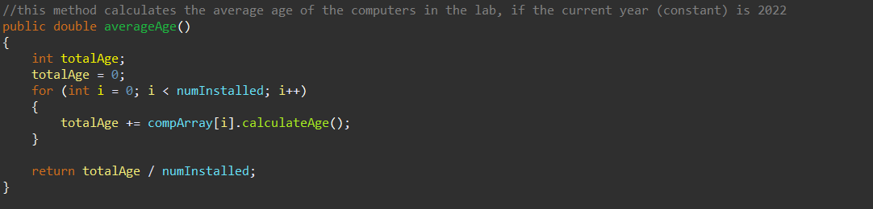

• A method that returns the newest computer in the lab

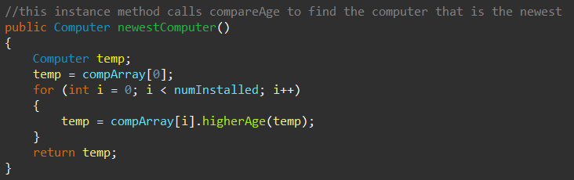

• A method that returns the faster computer (highest speed) in the lab

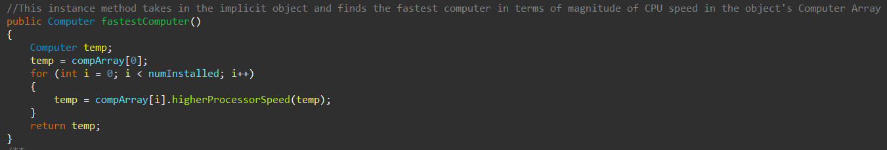

• A method that returns the computer with the largest size of RAM

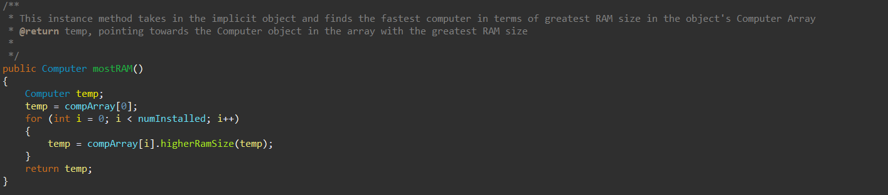

• A method that returns the number computers that are made by the given manufacturer (passed as parameter)

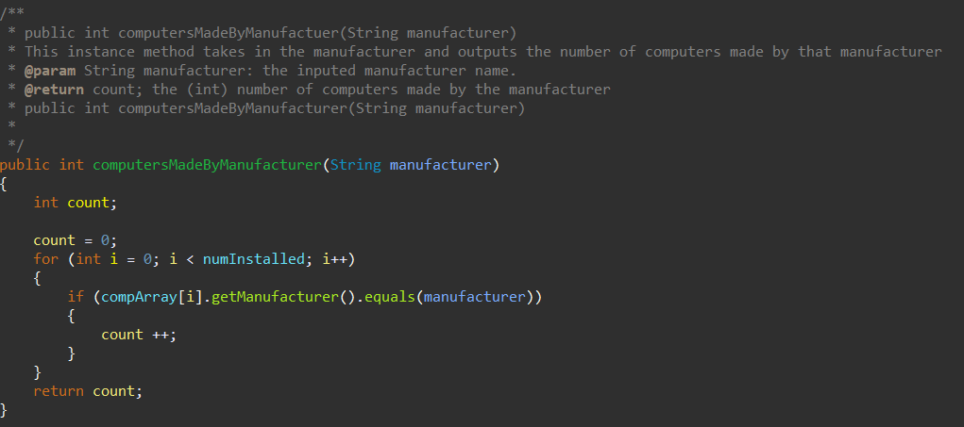

• (super tedious) A method that returns a list (an array) of computers that are expiring in the next year

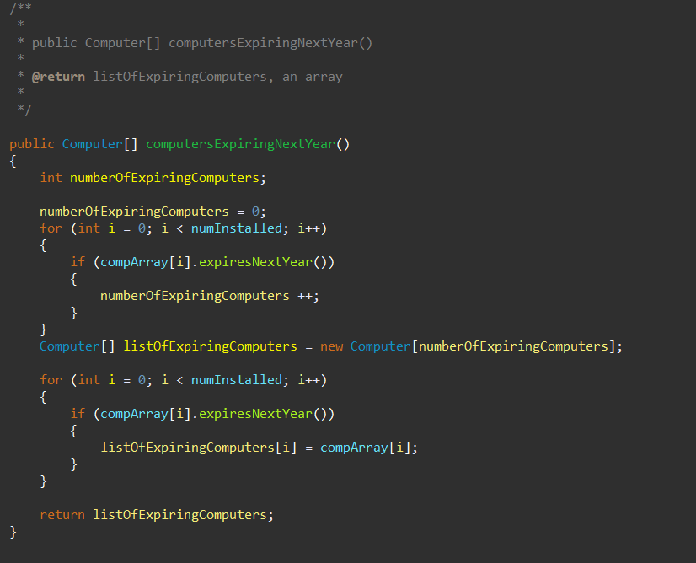

The LabTester Class

• Create the main method that perform the following tasks:

a. Ask user for the maximum capacity of the lab

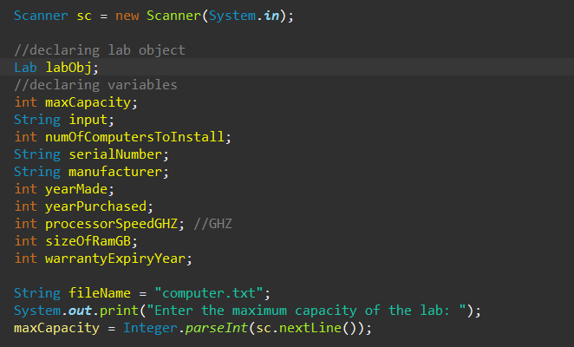

b. Obtain information of each computer from the text file

“computer.txt” and “install” each. “computer.txt” is in the following format:

5

D3423432X

Dell

2008

2009

1.5

2

2010

H23SD32PP HP

2010

2010

2.5

4

2015

:

:

This file contains information of 5 computers

Information of computer #1:

• Serial number

• Manufacturer

• Year of made

• Year of purchase

• Processor speed in GHz

• RAM size in GB

• Warranty expiry year

Information of computer #2

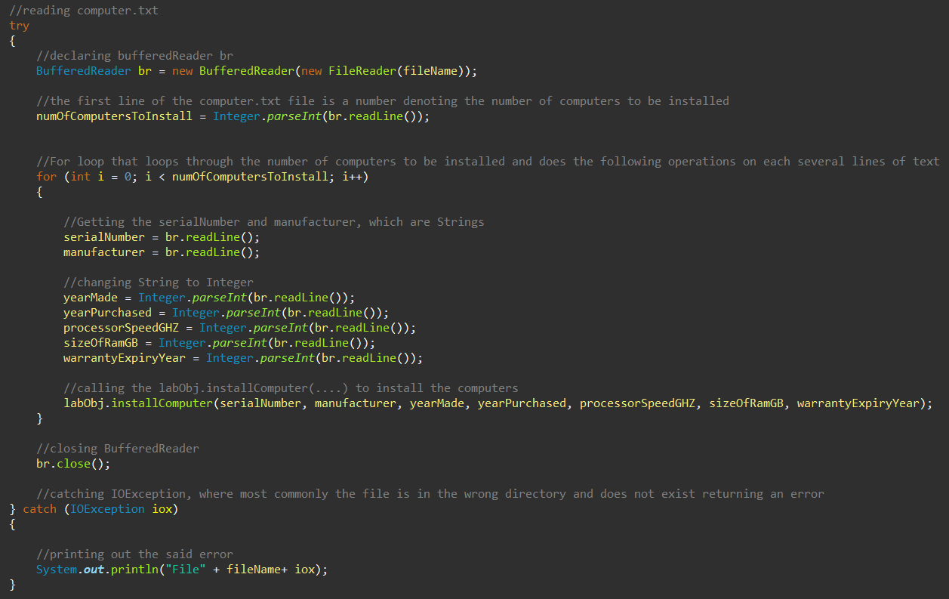c. Output average age of the computers in the lab

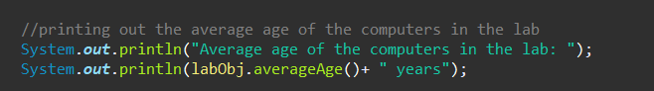

d. Output the spec of the newest computer



e. Output the spec of the faster computer (highest speed), and indicate if it has the largest size of RAM

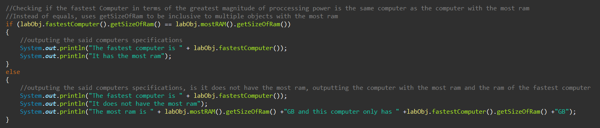

f. Ask user for a particular manufacturer, and output the number of computers with the manufacturer.

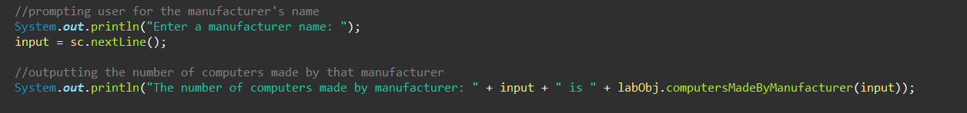

g. Output the serial number of all the computers that are expiring in the next year.

